Vertical Cross Section

Definition
# Source: AI Source: Provided by: [Data Path: Persons Table -> ID Column: 1, Name_En Column: Motasem Essam] -> From: [ChatGPT] on [7/25/2026]
A Vertical Cross Section is a two-dimensional geometric figure formed when a three-dimensional solid is intersected by a vertical plane that is perpendicular to the solid's horizontal base plane.
The vertical plane passes through the solid from one side to another, producing a cross-sectional shape determined by the solid's geometry and the position and direction of the cutting plane.
A vertical cross-section may pass through the central axis of the solid or be positioned away from it.
The resulting shape can be a rectangle, triangle, circle, polygon, or another geometric figure.
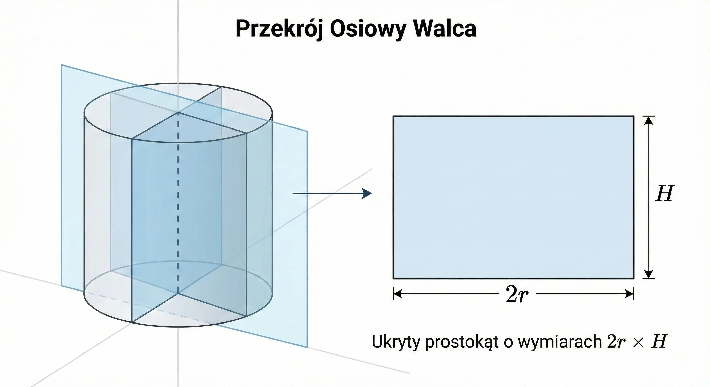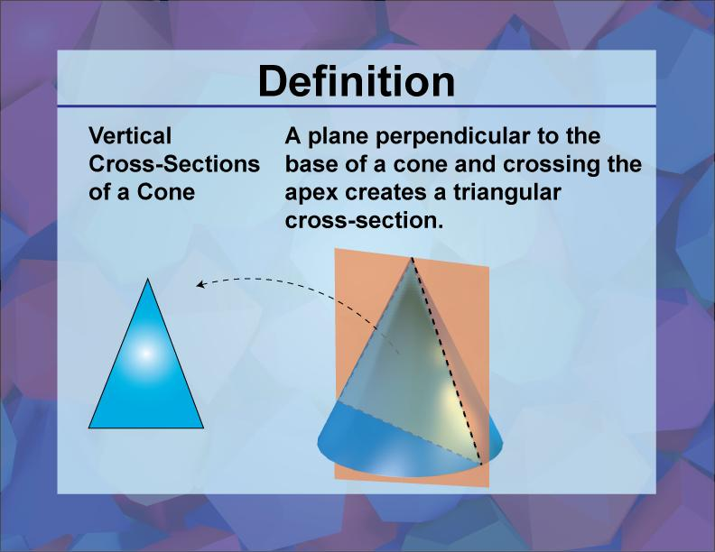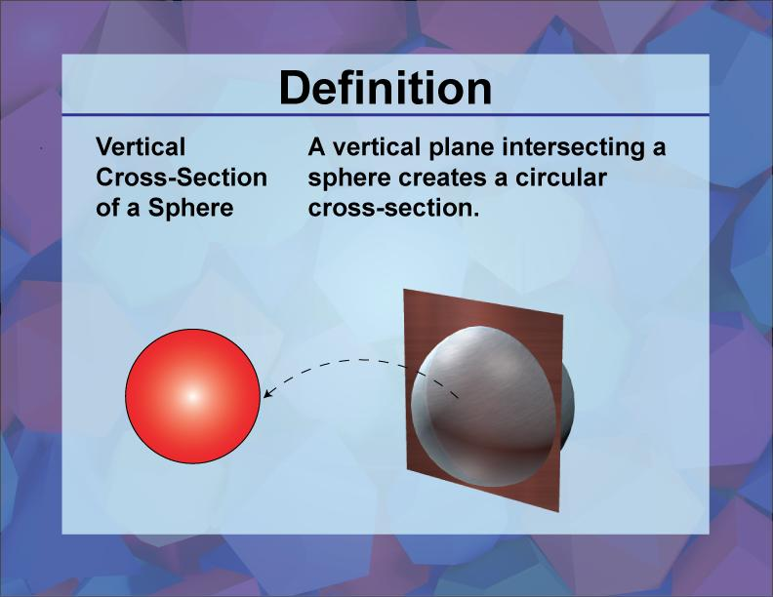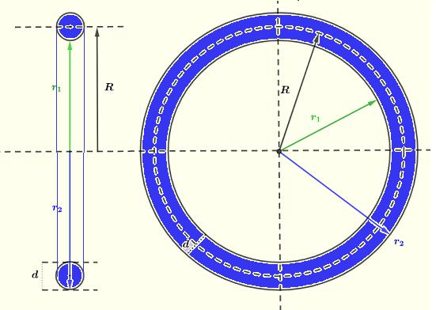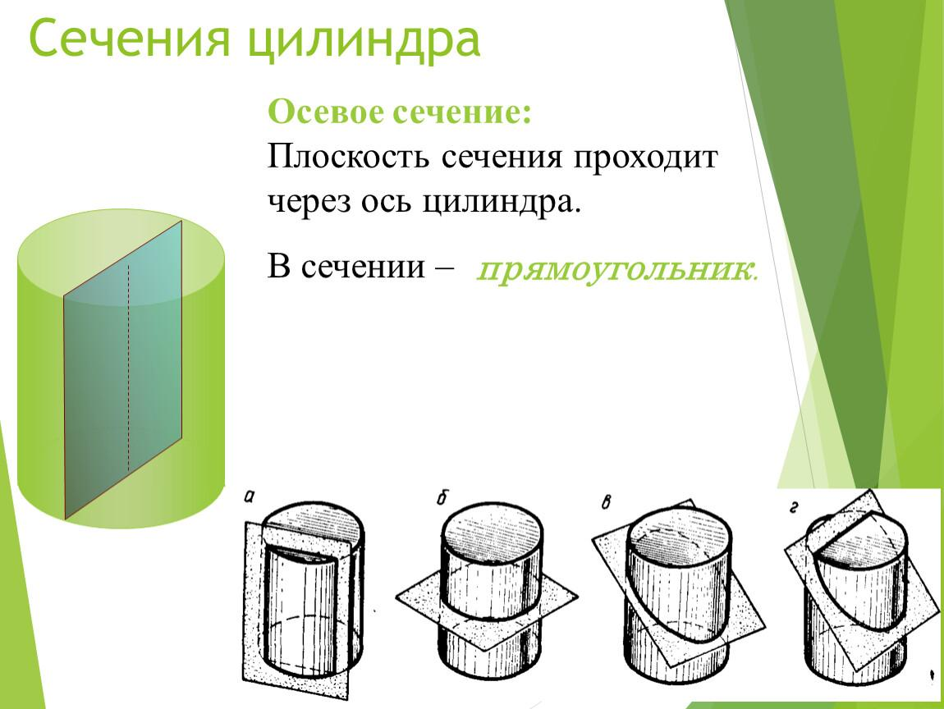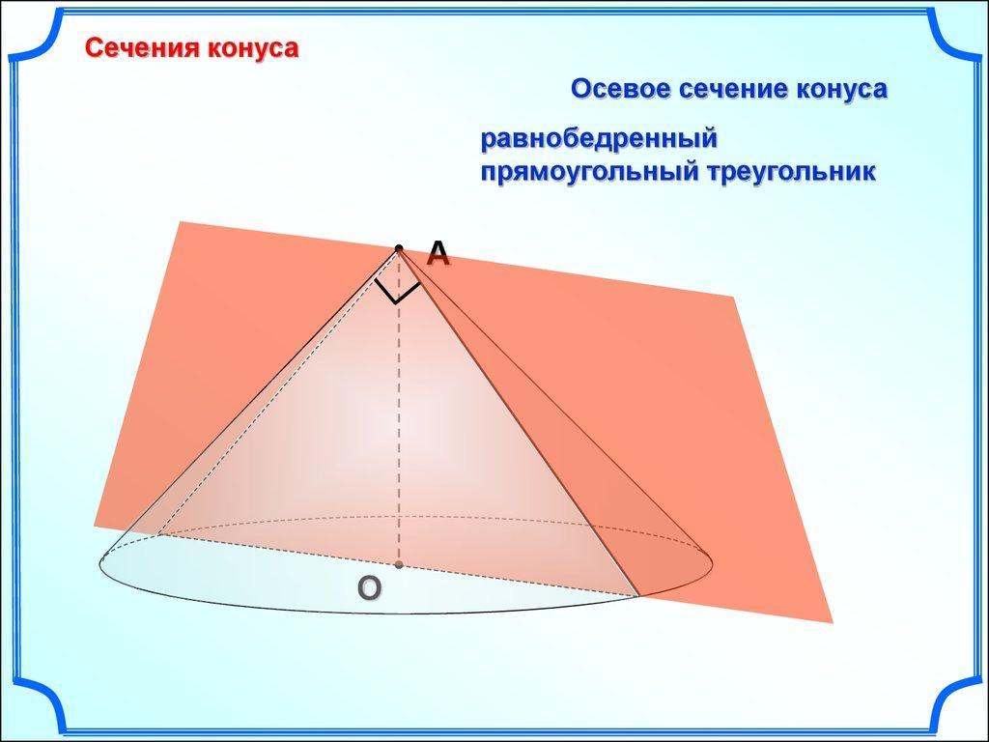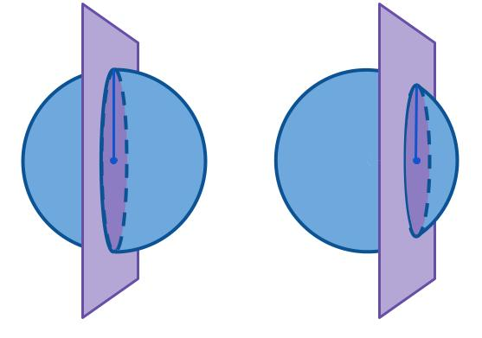

Geometric Structure
# Source: AI Source: Provided by: [Data Path: Persons Table -> ID Column: 1, Name_En Column: Motasem Essam] -> From: [ChatGPT] on [7/25/2026]
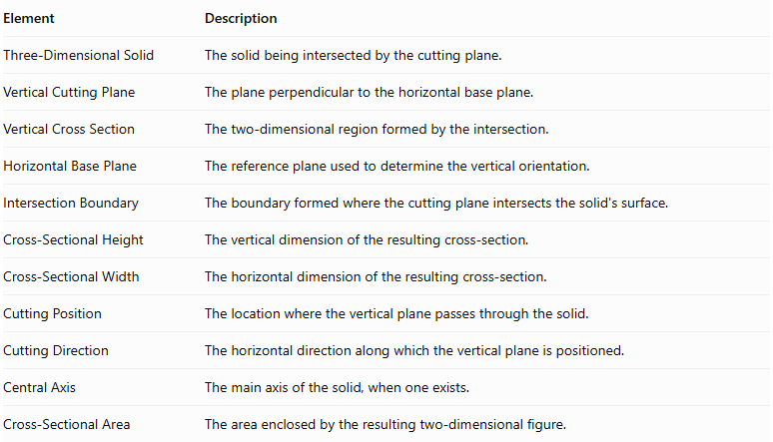
Element | Description
Three-Dimensional Solid | The solid being intersected by the cutting plane.
Vertical Cutting Plane | The plane perpendicular to the horizontal base plane.
Vertical Cross Section | The two-dimensional region formed by the intersection.
Horizontal Base Plane | The reference plane used to determine the vertical orientation.
Intersection Boundary | The boundary formed where the cutting plane intersects the solid's surface.
Cross-Sectional Height | The vertical dimension of the resulting cross-section.
Cross-Sectional Width | The horizontal dimension of the resulting cross-section.
Cutting Position | The location where the vertical plane passes through the solid.
Cutting Direction | The horizontal direction along which the vertical plane is positioned.
Central Axis | The main axis of the solid, when one exists.
Cross-Sectional Area | The area enclosed by the resulting two-dimensional figure.

Main Characteristics
# Source: AI Source: Provided by: [Data Path: Persons Table -> ID Column: 1, Name_En Column: Motasem Essam] -> From: [ChatGPT] on [7/25/2026]
- The cutting plane is perpendicular to the horizontal base plane.
- The cutting plane extends vertically through the solid.
- The resulting cross-section is two-dimensional.
- The cross-sectional shape depends on the geometry of the solid.
- The position of the cutting plane affects the dimensions and sometimes the shape of the cross-section.
- A vertical plane may pass through the central axis or away from it.
- A vertical cross-section can be symmetrical or asymmetrical.
- Multiple vertical planes can produce different cross-sections of the same solid.

Types of Vertical Cross Sections According to Cutting Position

Central Vertical Cross Section
# Source: AI Source: Provided by: [Data Path: Persons Table -> ID Column: 1, Name_En Column: Motasem Essam] -> From: [ChatGPT] on [7/25/2026]
A Central Vertical Cross Section is formed when a vertical plane passes through the central axis or center of symmetry of a solid.
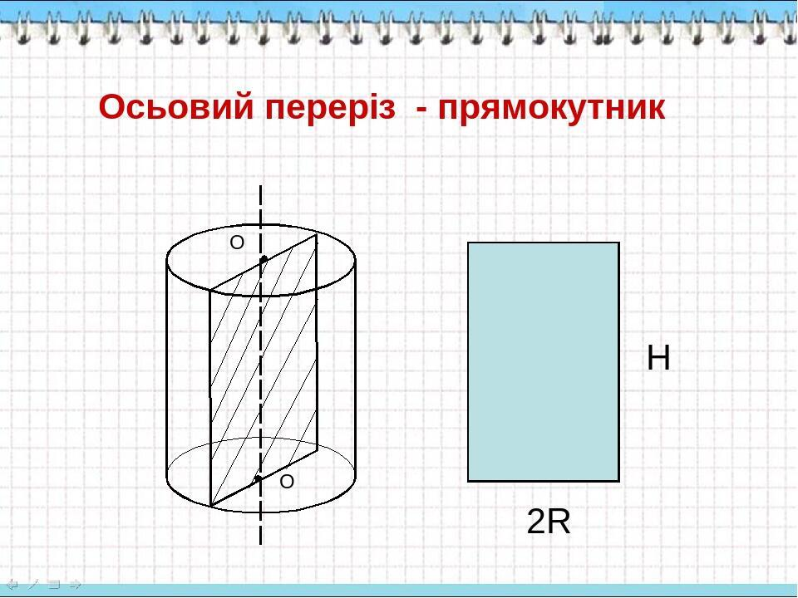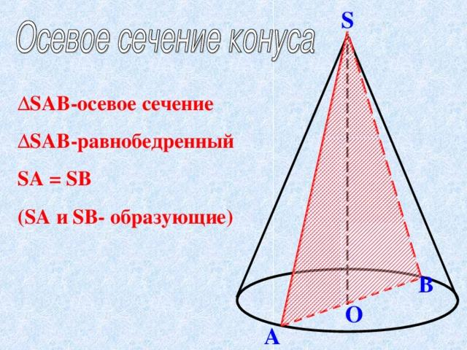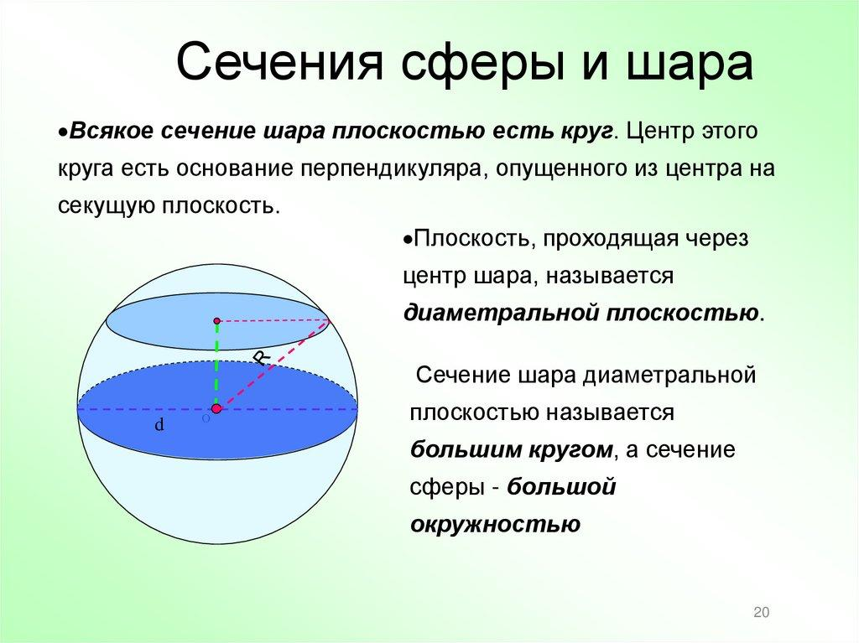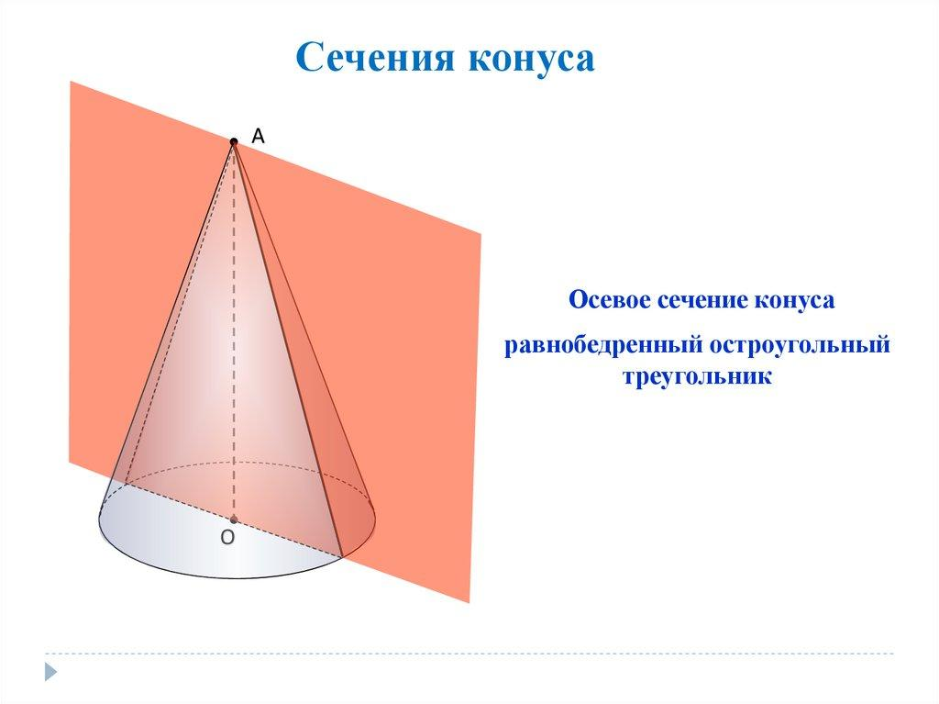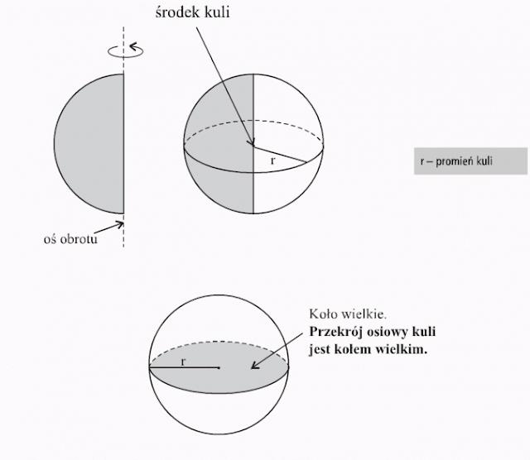
Examples:
- Right Circular Cylinder → Rectangle when the plane contains its central axis.
- Right Circular Cone → Isosceles Triangle when the plane contains its axis and apex.
- Sphere → Great Circle when the plane passes through its center.
- Right Circular Pyramid → A polygonal section, often a triangle, when the plane passes through its apex and a suitable line in the base.

Off-Center Vertical Cross Section
# Source: AI Source: Provided by: [Data Path: Persons Table -> ID Column: 1, Name_En Column: Motasem Essam] -> From: [ChatGPT] on [7/25/2026]
An Off-Center Vertical Cross Section is formed when a vertical plane intersects a solid without passing through its central axis or center of symmetry.
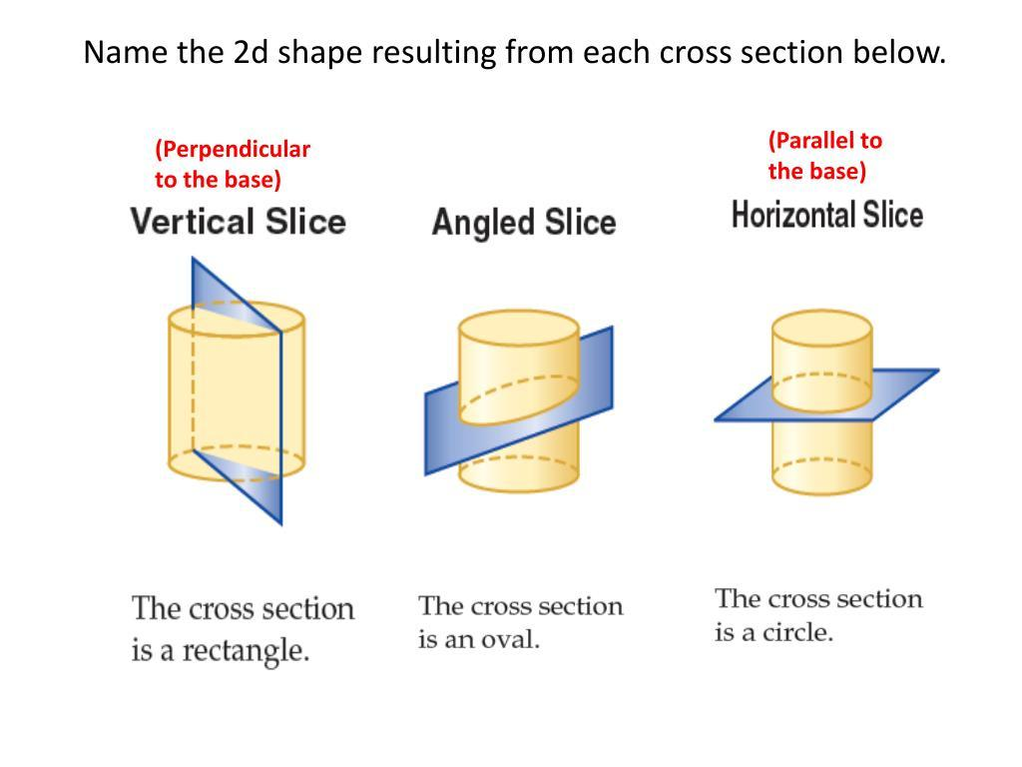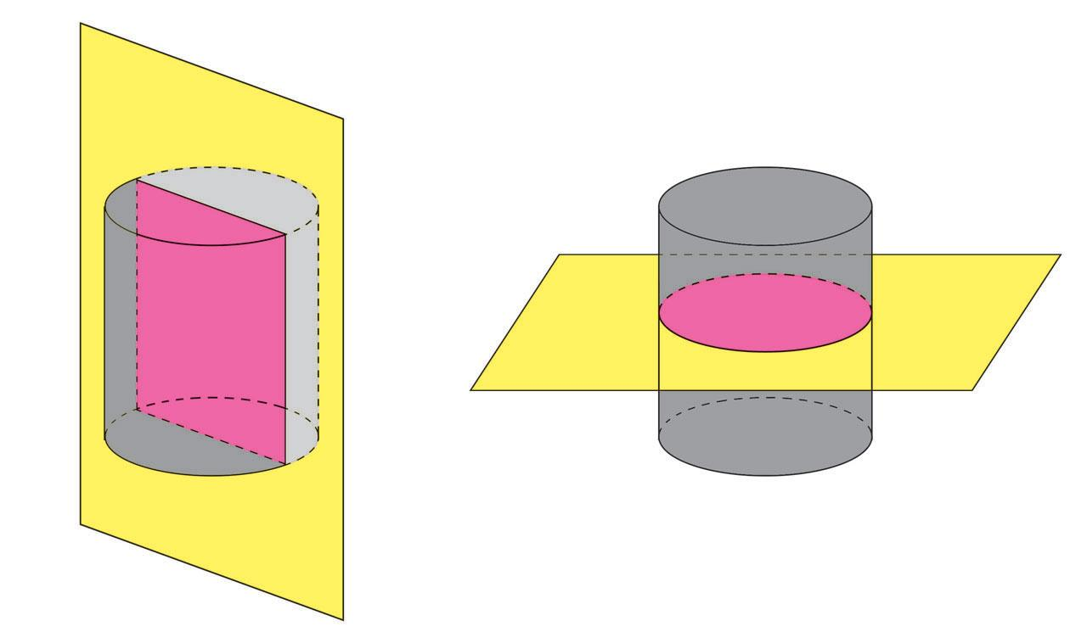
Examples:
- Cylinder → Rectangle, generally narrower than the central axial section.
- Sphere → Circle smaller than the great circle.
- Cone → A section whose boundary depends on the plane's position relative to the apex and cone surface.
- Pyramid → A polygonal cross-section whose shape and dimensions depend on the cutting position.

Types of Vertical Cross Sections According to Geometric Shape

Rectangular Vertical Cross Section
# Source: AI Source: Provided by: [Data Path: Persons Table -> ID Column: 1, Name_En Column: Motasem Essam] -> From: [ChatGPT] on [7/25/2026]
A Rectangular Vertical Cross Section is a vertical cross-section whose boundary forms a rectangle.
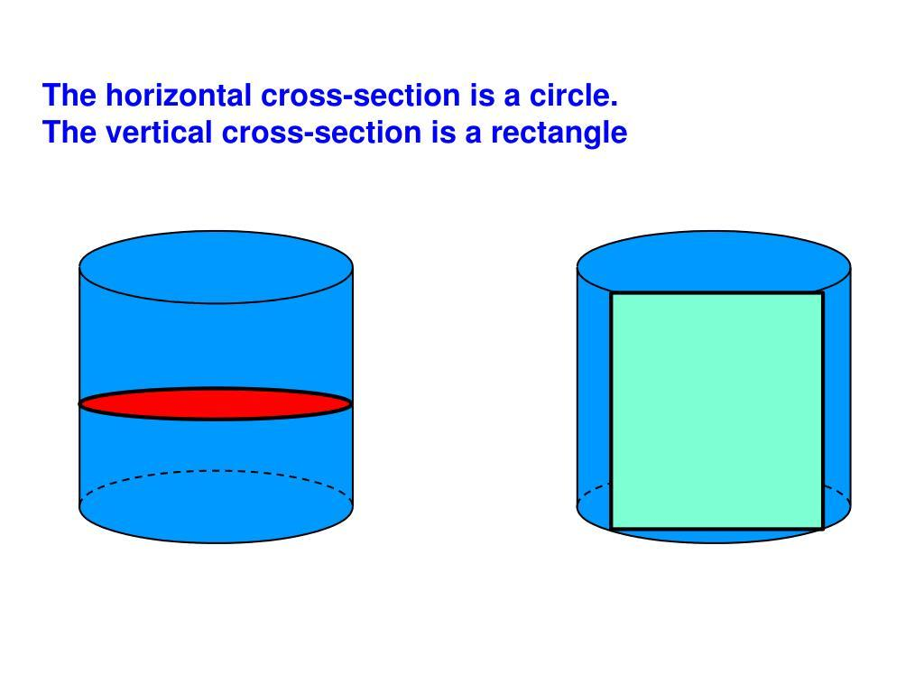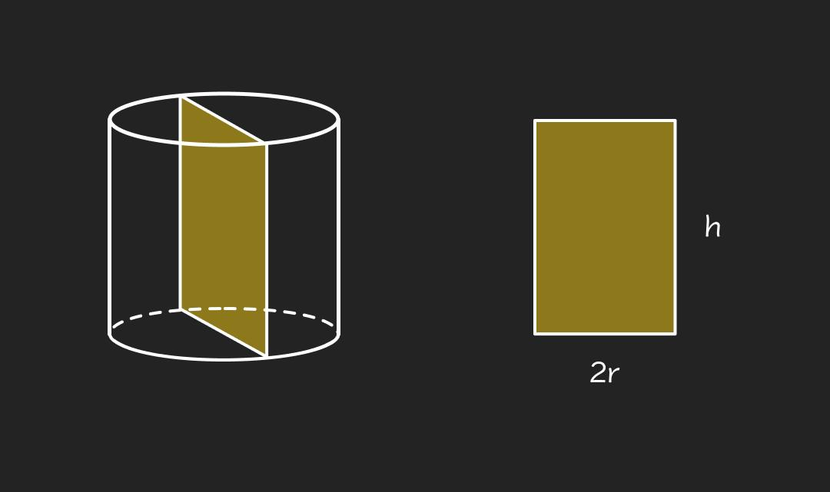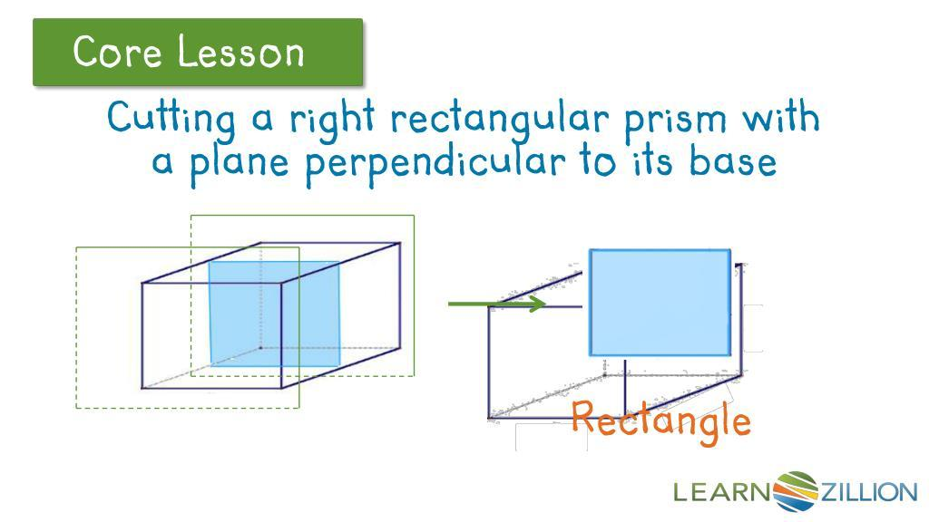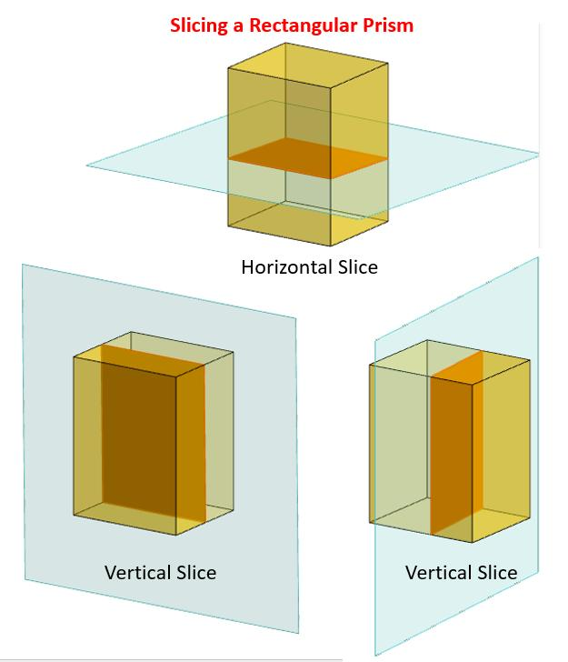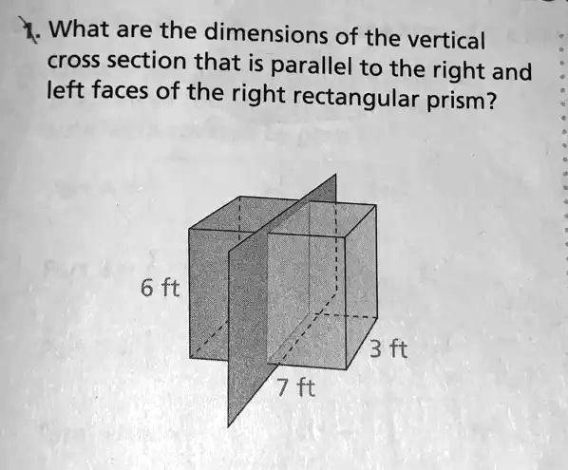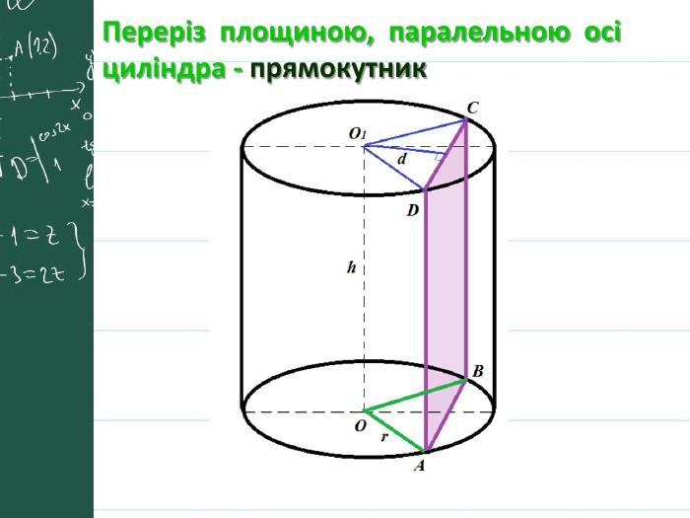
Common examples:
- Right Circular Cylinder cut by a vertical plane parallel to its axis.
- Rectangular Prism cut by a suitable vertical plane.
- Cube cut by a vertical plane parallel to one of its vertical faces.
For a right circular cylinder with radius $r$ and height $h$, a vertical plane passing through its axis produces a rectangle with:
$$w=2r$$
$$A=2rh$$
Where:
- $w$ = cross-sectional width.
- $h$ = cylinder height.
- $r$ = cylinder radius.
For an off-center vertical cut at distance $d$ from the cylinder's axis:
$$w=2\sqrt{r^{2}-d^{2}}$$
$$A=2h\sqrt{r^{2}-d^{2}}$$

Triangular Vertical Cross Section
# Source: AI Source: Provided by: [Data Path: Persons Table -> ID Column: 1, Name_En Column: Motasem Essam] -> From: [ChatGPT] on [7/25/2026]
A Triangular Vertical Cross Section is a vertical cross-section whose boundary forms a triangle.
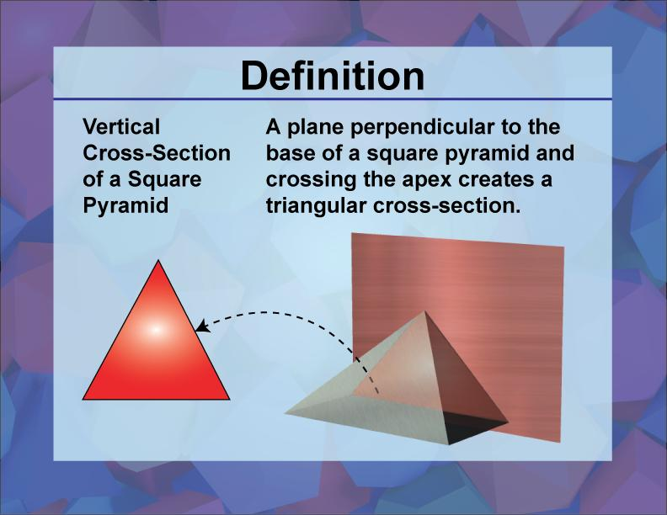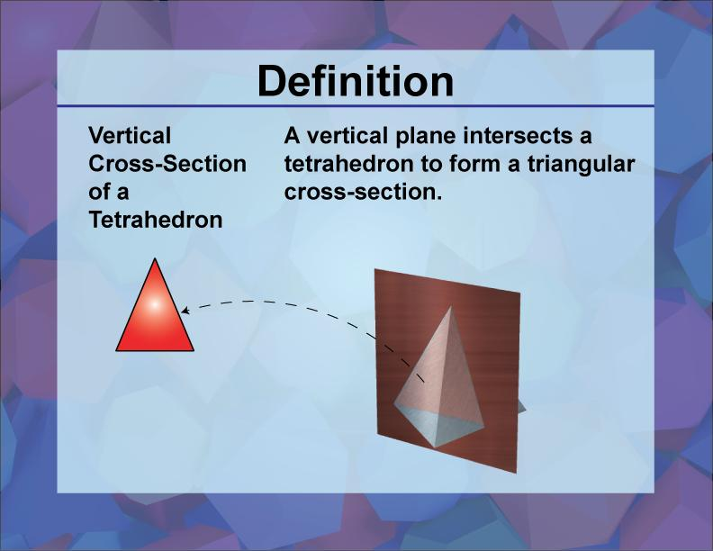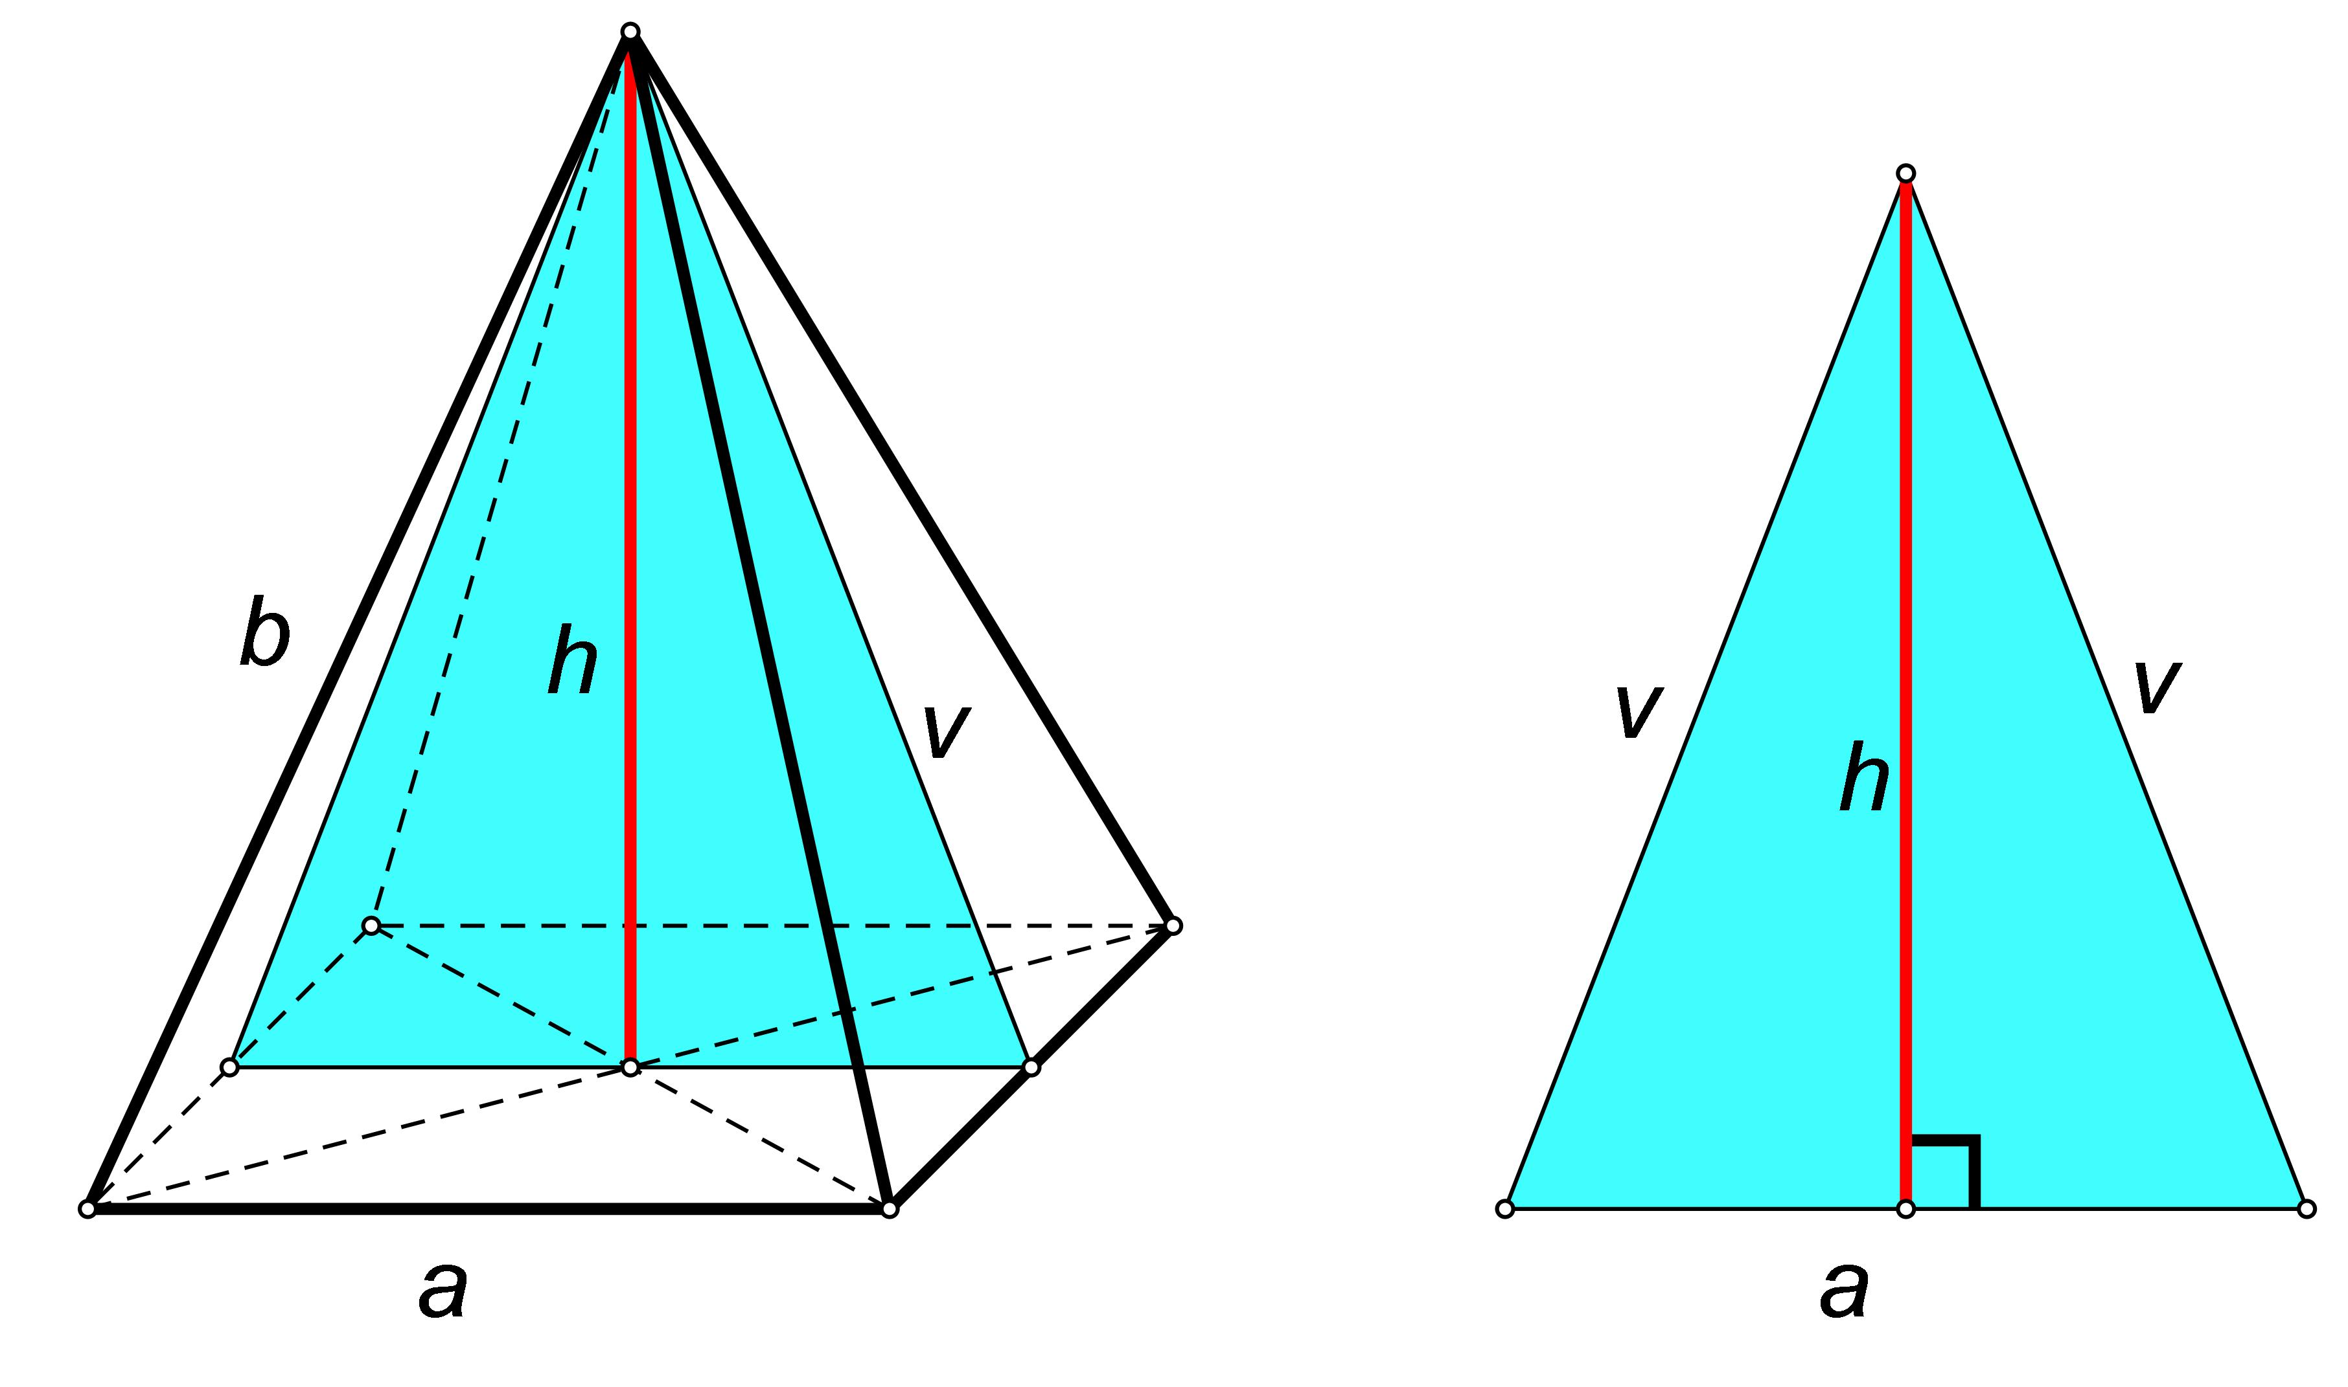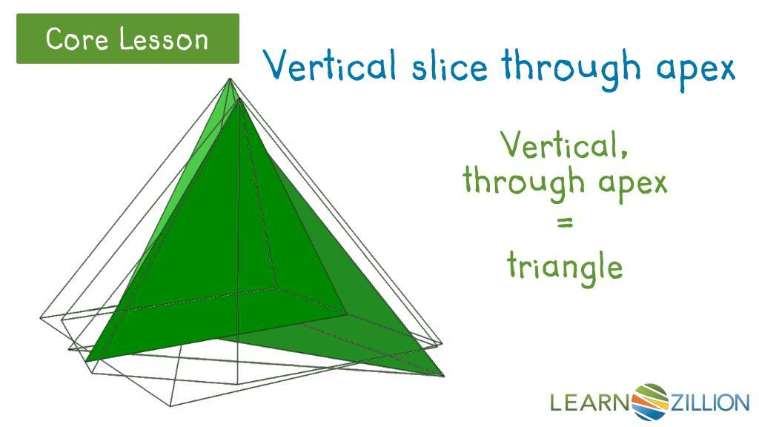
Common examples:
- Right Circular Cone cut by a vertical plane containing its axis.
- Right Square Pyramid cut by a vertical plane passing through its apex and an appropriate line in its base.
- Other pyramids cut through their apexes.
For an axial cross-section of a right circular cone:
$$A=\frac{1}{2}(2r)h$$
Therefore:
$$\boxed{A=rh}$$
Where:
- $r$ = cone base radius.
- $h$ = cone height.

Circular Vertical Cross Section
# Source: AI Source: Provided by: [Data Path: Persons Table -> ID Column: 1, Name_En Column: Motasem Essam] -> From: [ChatGPT] on [7/25/2026]
A Circular Vertical Cross Section is a cross-section whose boundary forms a circle.
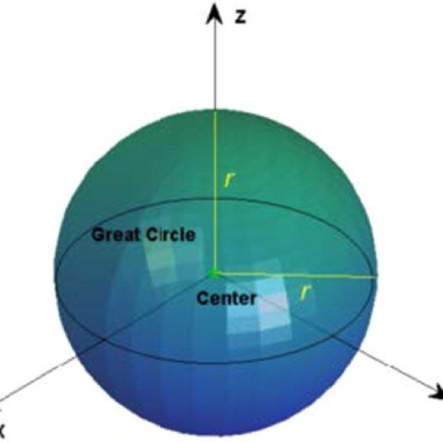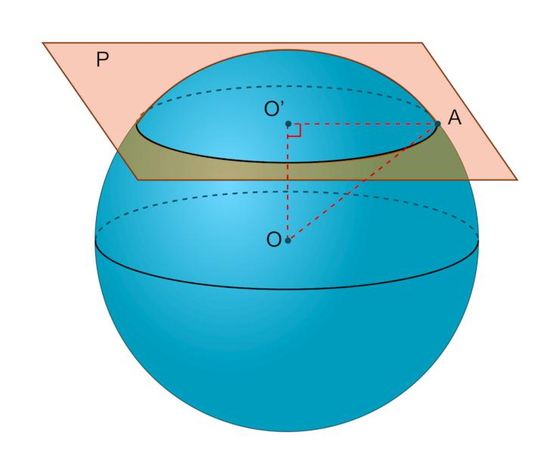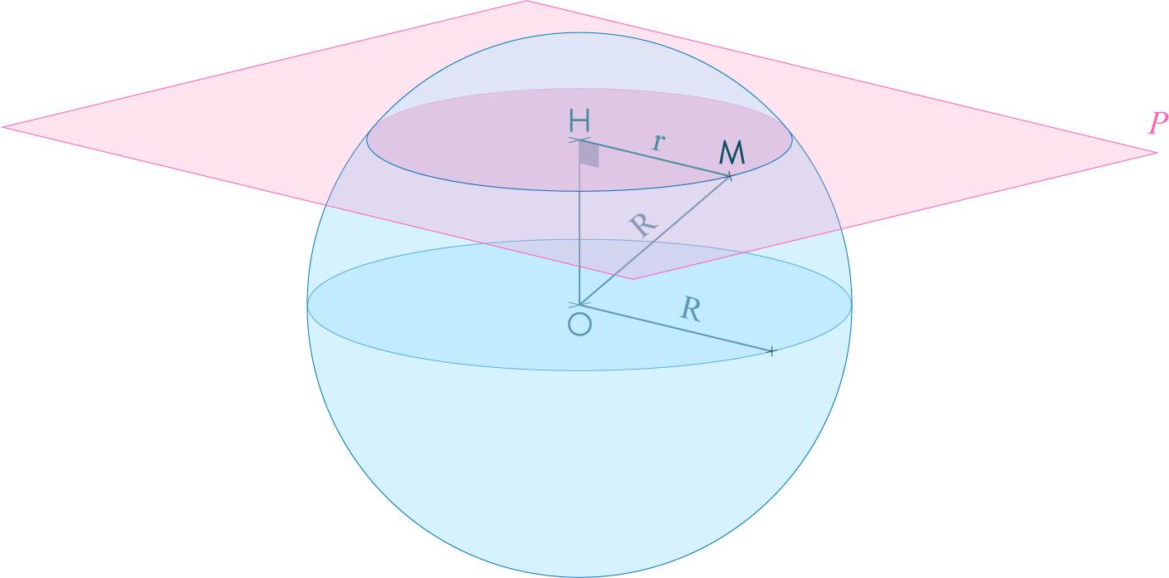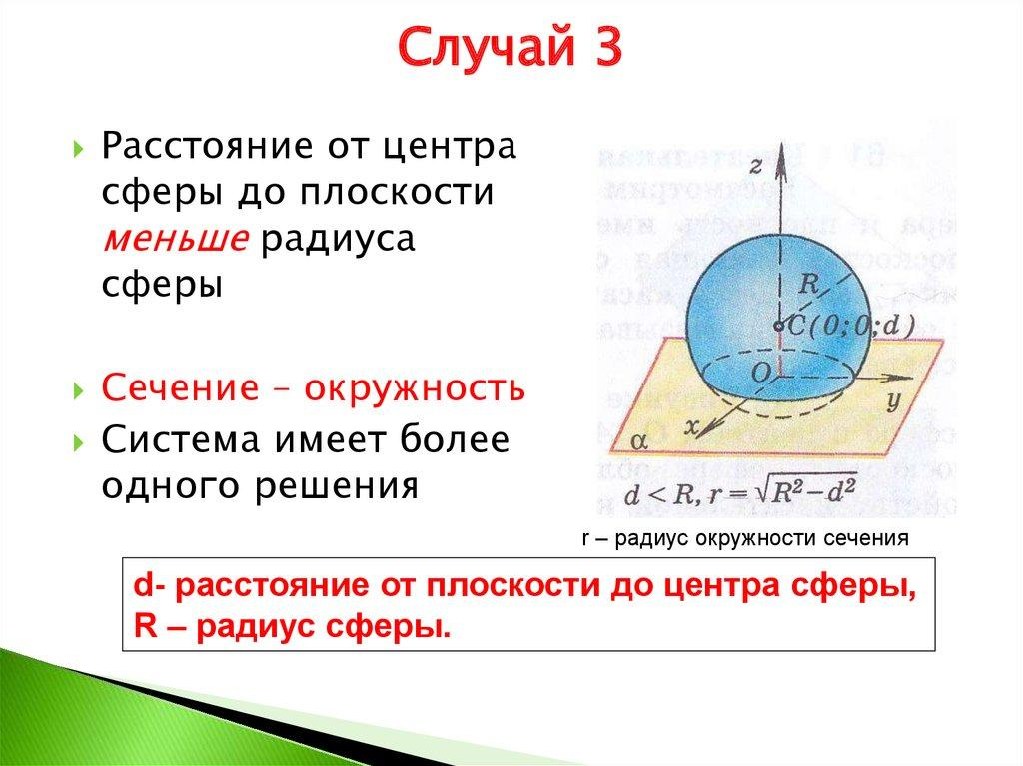
A sphere produces a circular cross-section whenever a plane intersects its interior, regardless of the plane's orientation.
For a sphere with radius $R$, and a cutting plane at perpendicular distance $d$ from its center:
$$r=\sqrt{R^{2}-d^{2}}$$
Cross-sectional area:
$$\boxed{A=π(R^{2}-d^{2})}$$
The largest circular cross-section occurs when the plane passes through the center. It is called a Great Circle.

Polygonal Vertical Cross Section
# Source: AI Source: Provided by: [Data Path: Persons Table -> ID Column: 1, Name_En Column: Motasem Essam] -> From: [ChatGPT] on [7/25/2026]
A Polygonal Vertical Cross Section is a vertical cross-section whose boundary consists of straight line segments forming a polygon.
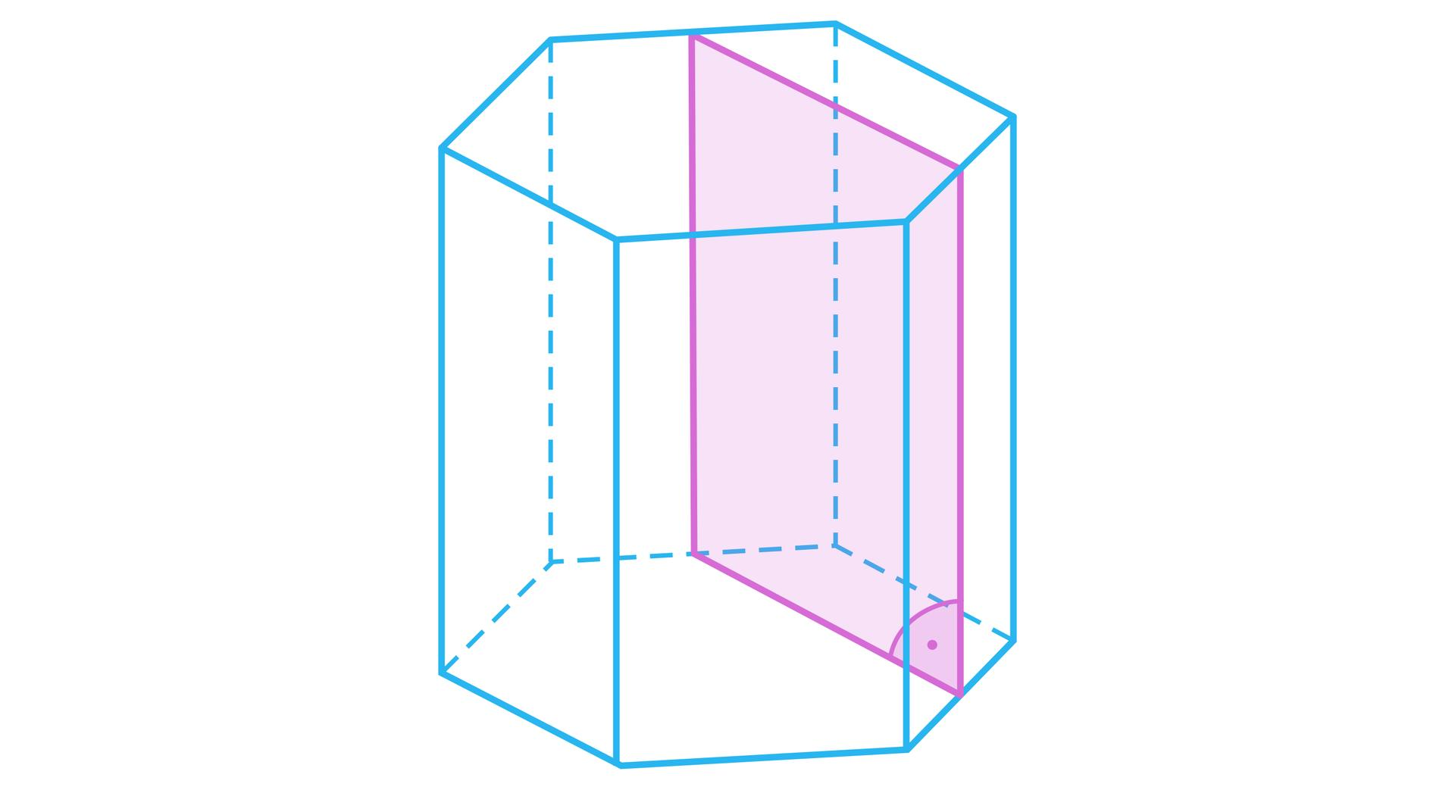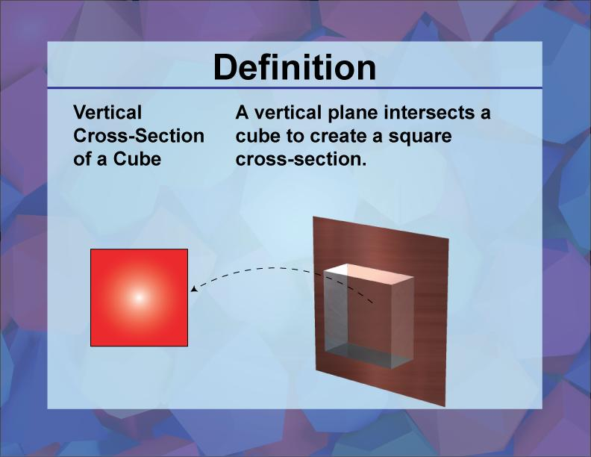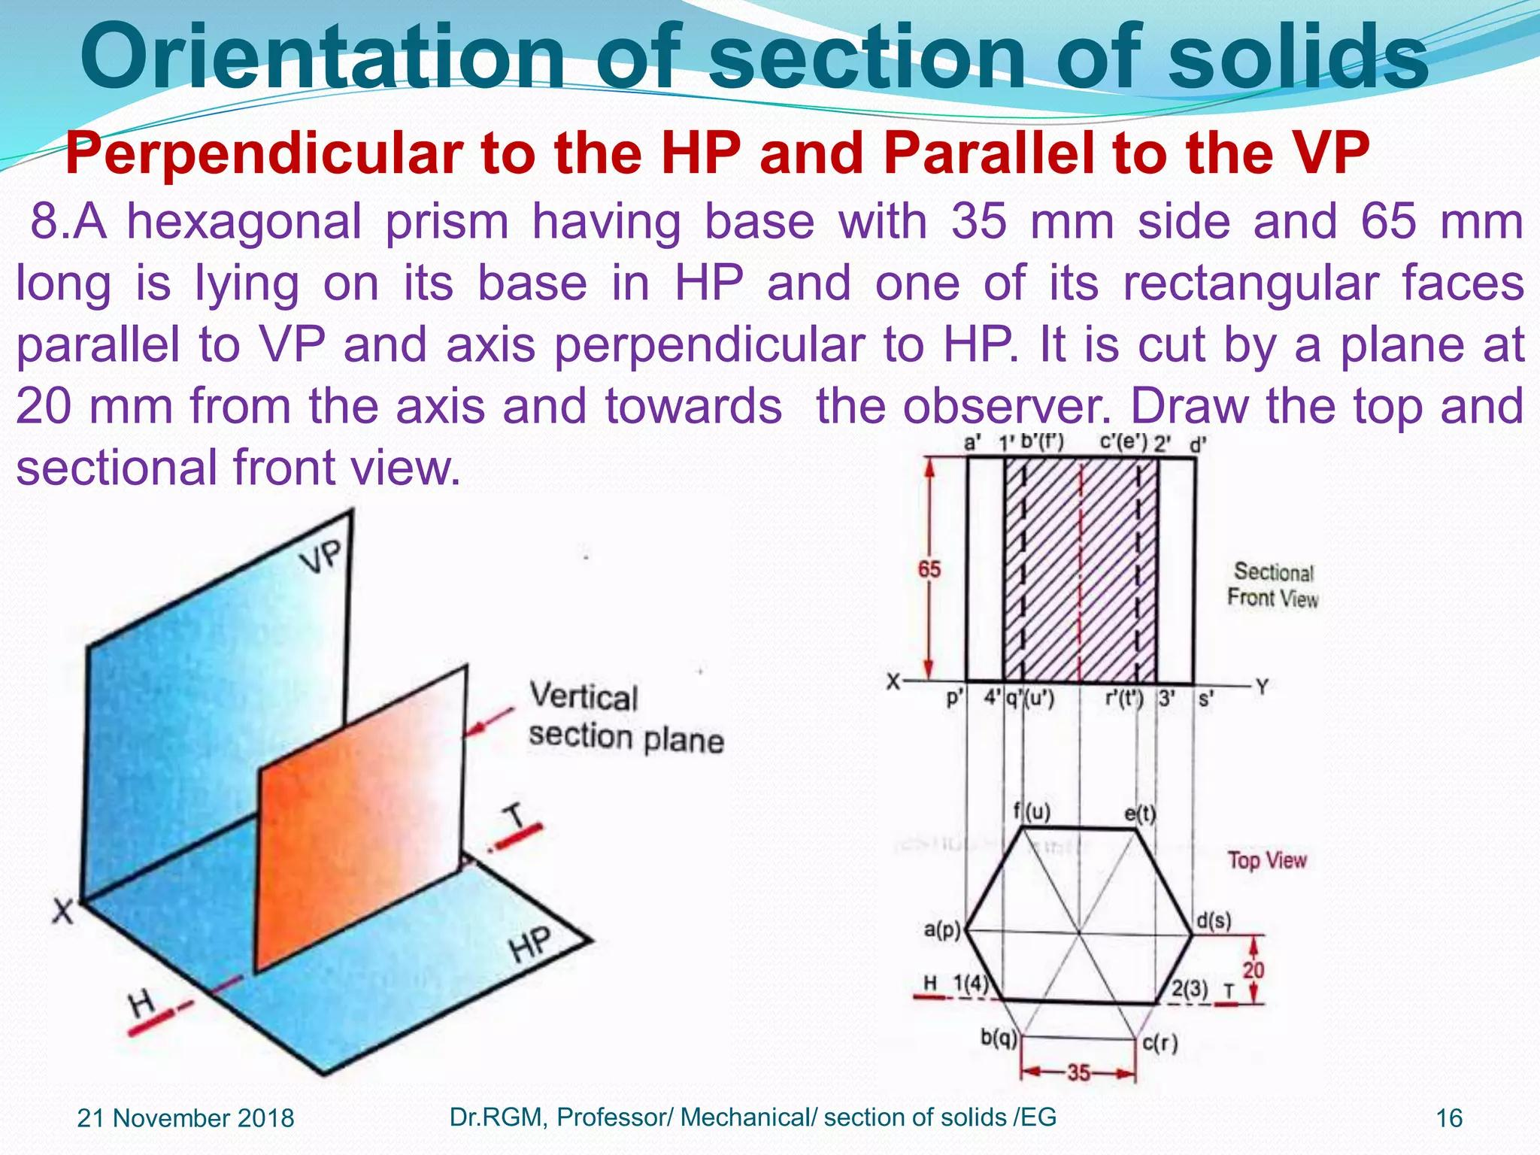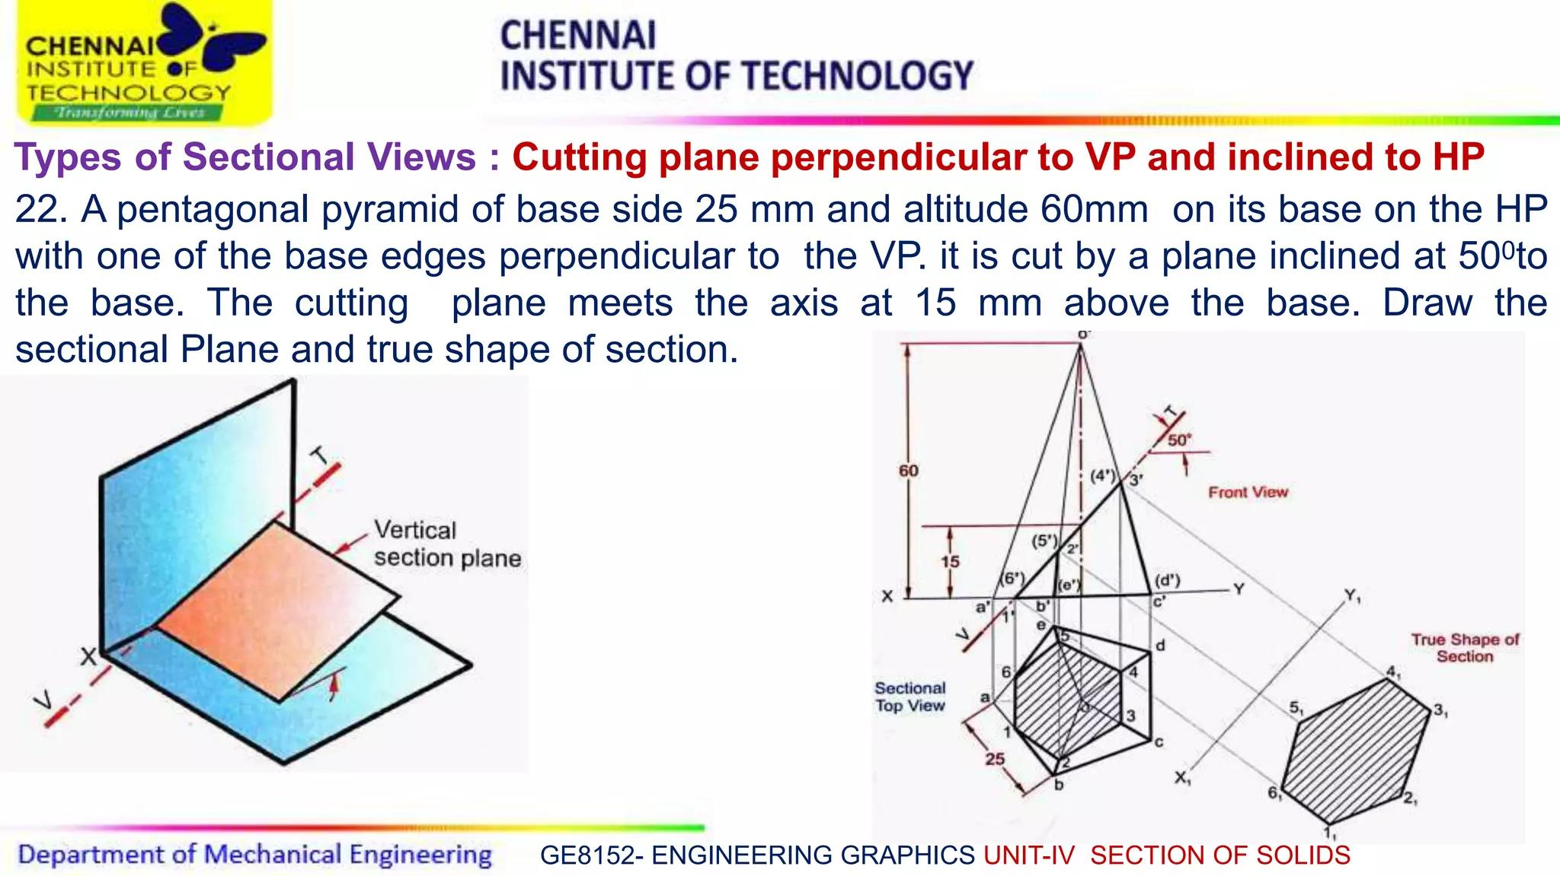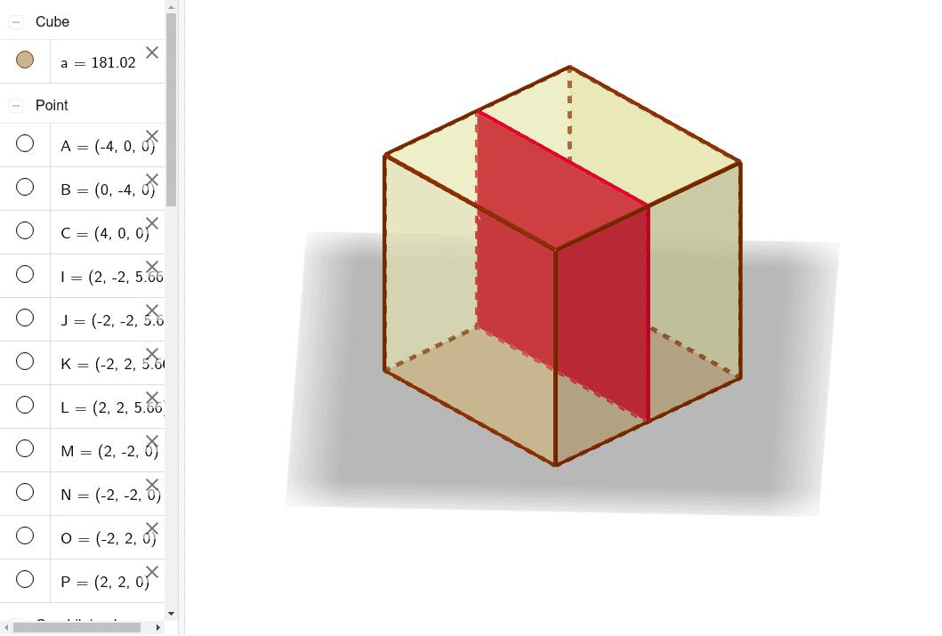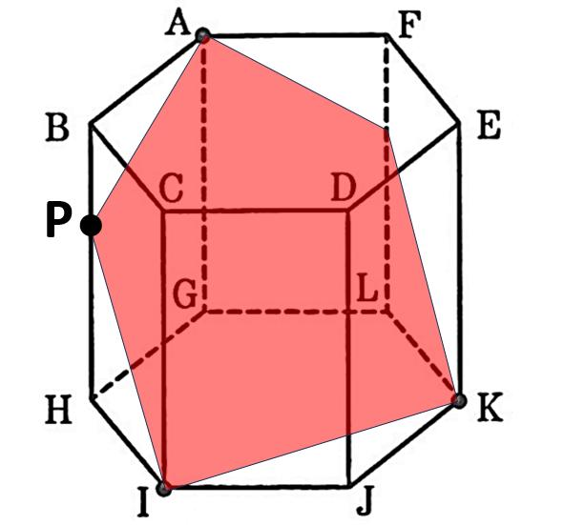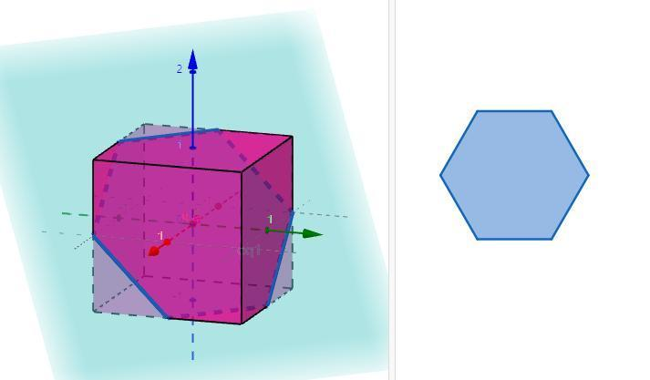
Possible shapes include:
- Triangular Cross Section.
- Quadrilateral Cross Section.
- Pentagonal Cross Section.
- Hexagonal Cross Section.
- Other Polygonal Cross Sections.
The resulting polygon depends on the number of faces intersected by the vertical plane and the position of that plane.

Curvilinear Vertical Cross Section
# Source: AI Source: Provided by: [Data Path: Persons Table -> ID Column: 1, Name_En Column: Motasem Essam] -> From: [ChatGPT] on [7/25/2026]
A Curvilinear Vertical Cross Section is a cross-section whose boundary contains one or more curved portions.
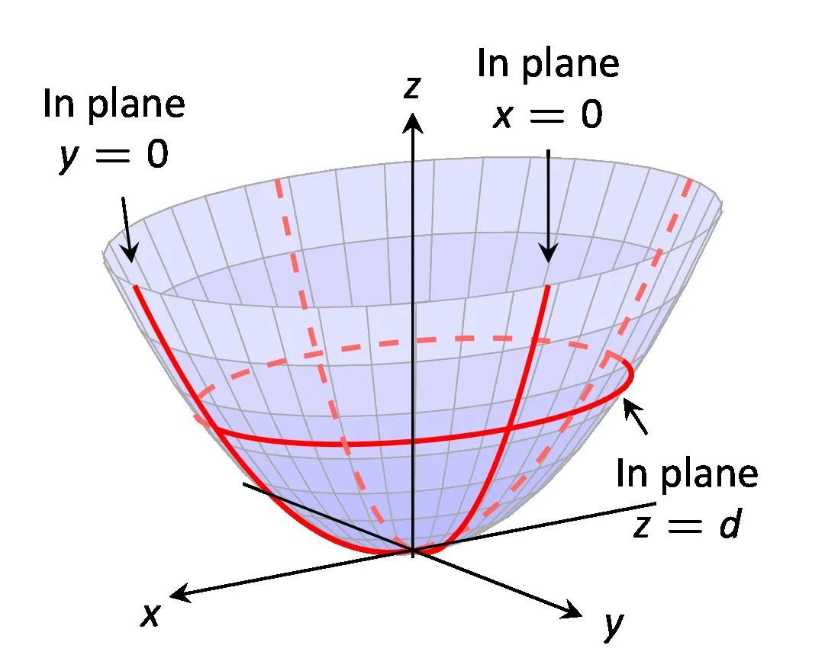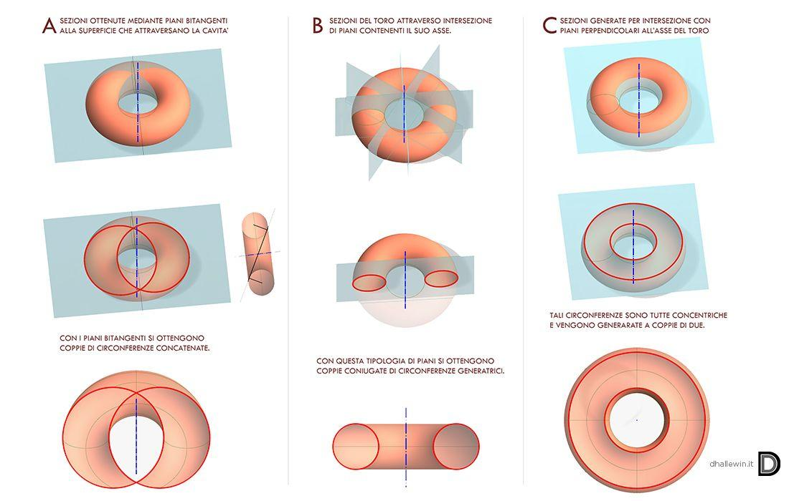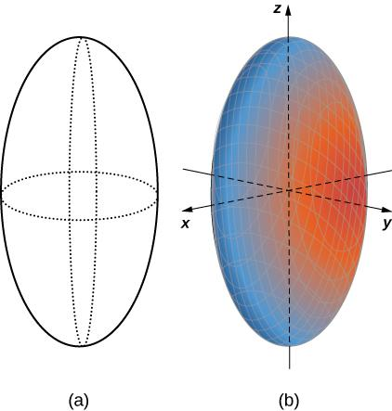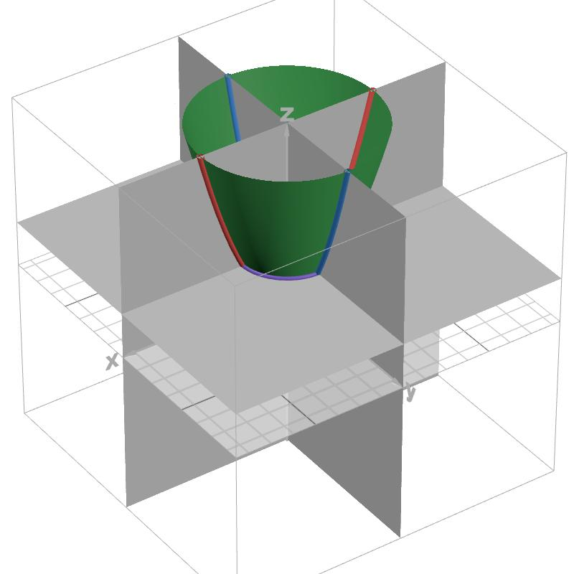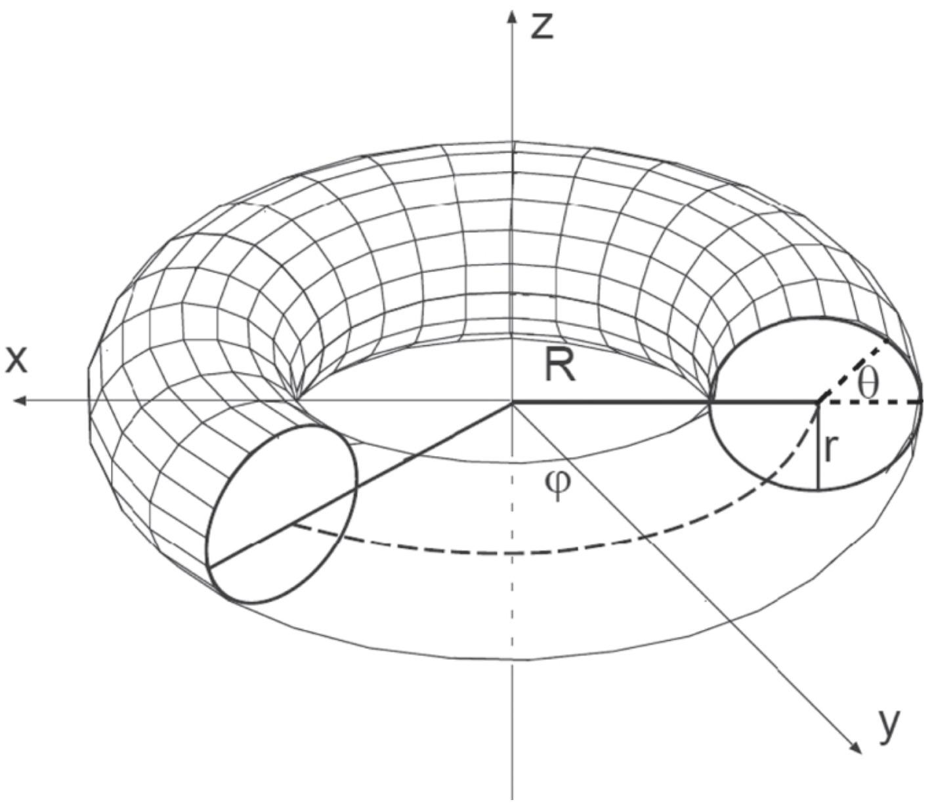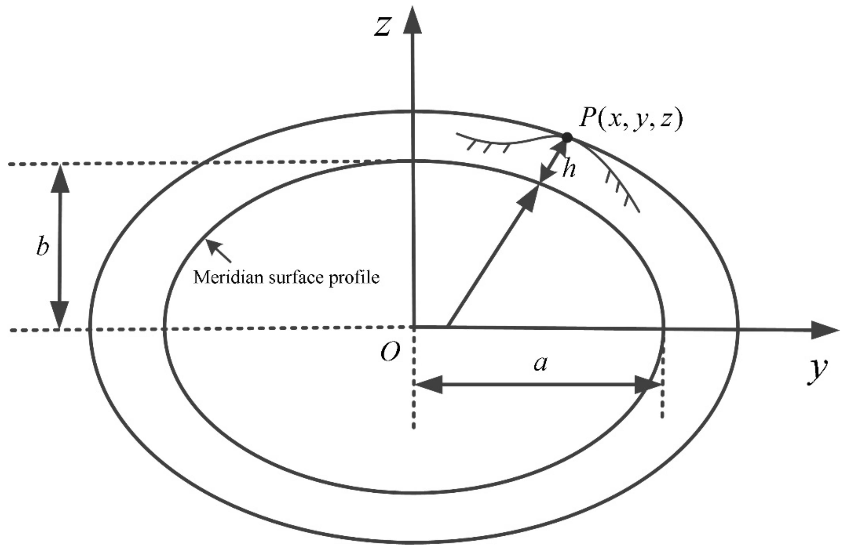
Examples:
- Torus → A vertical central plane through its axis of symmetry produces two circular cross-sectional regions for a standard ring torus.
- Paraboloid → A vertical axial section produces a parabolic profile.
- Ellipsoid → A vertical section through its center produces an ellipse.
- Other curved solids → Sections with curved or mixed straight-and-curved boundaries.

Vertical Cross Sections of Common Geometric Solids
# Source: AI Source: Provided by: [Data Path: Persons Table -> ID Column: 1, Name_En Column: Motasem Essam] -> From: [ChatGPT] on [7/25/2026]
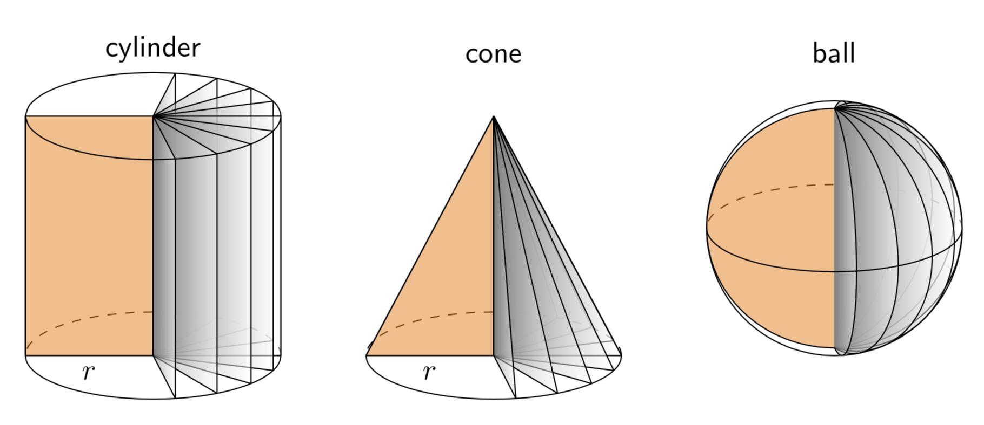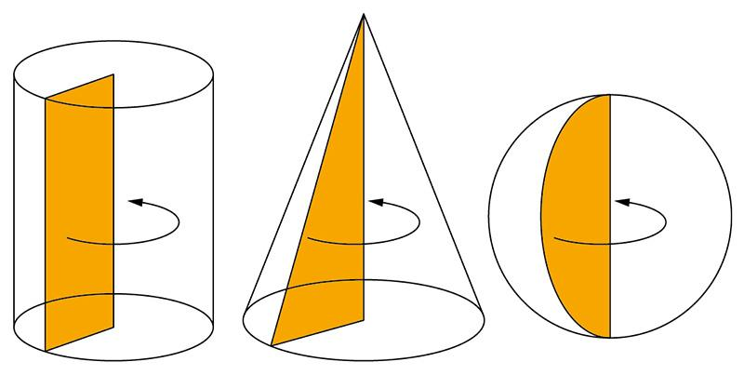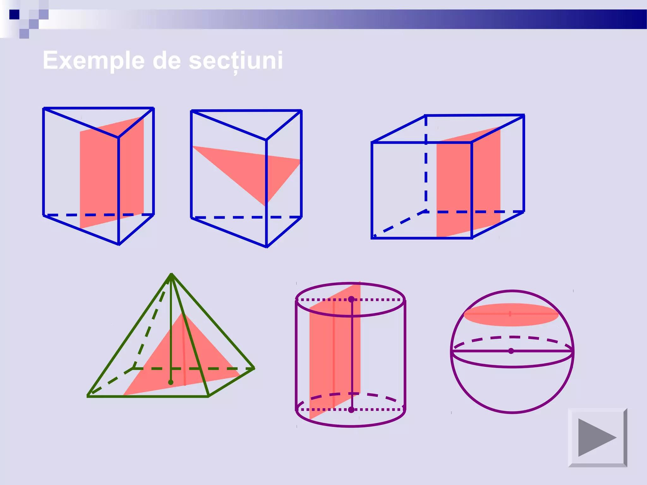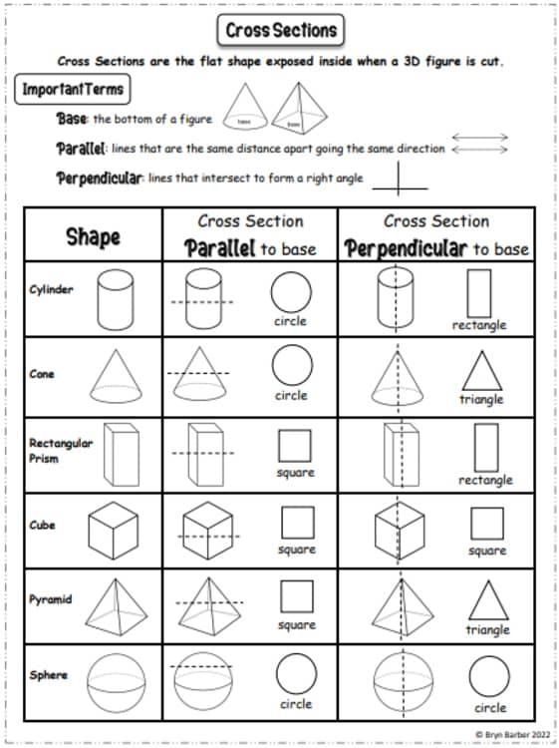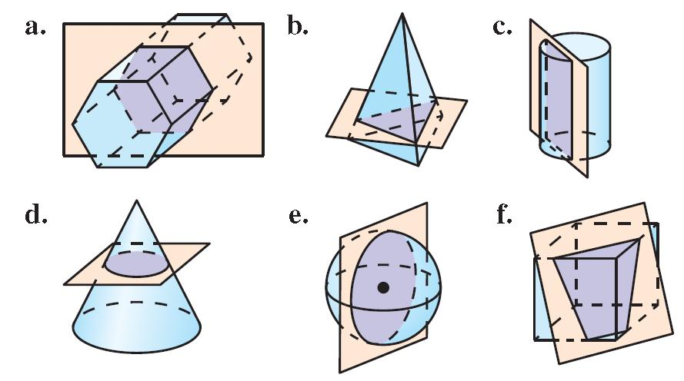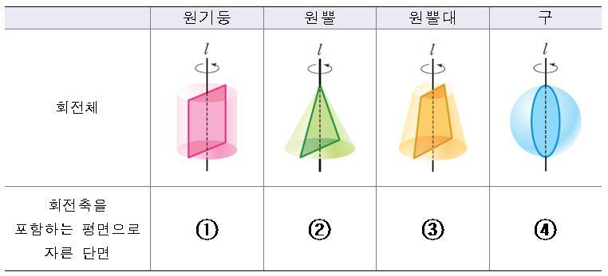
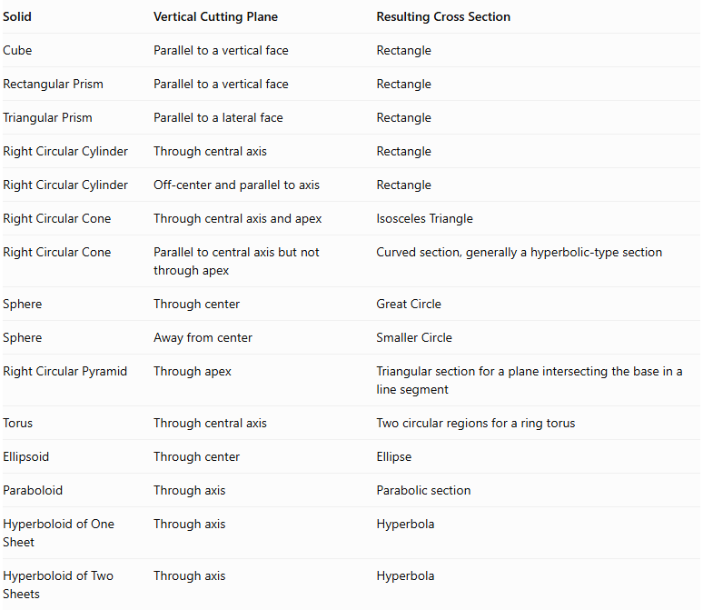
Solid | Vertical Cutting Plane | Resulting Cross Section
Cube | Parallel to a vertical face | Rectangle
Rectangular Prism | Parallel to a vertical face | Rectangle
Triangular Prism | Parallel to a lateral face | Rectangle
Right Circular Cylinder | Through central axis | Rectangle
Right Circular Cylinder | Off-center and parallel to axis | Rectangle
Right Circular Cone | Through central axis and apex | Isosceles Triangle
Right Circular Cone | Parallel to central axis but not through apex | Curved section, generally a hyperbolic-type section
Sphere | Through center | Great Circle
Sphere | Away from center | Smaller Circle
Right Circular Pyramid | Through apex | Triangular section for a plane intersecting the base in a line segment
Torus | Through central axis | Two circular regions for a ring torus
Ellipsoid | Through center | Ellipse
Paraboloid | Through axis | Parabolic section
Hyperboloid of One Sheet | Through axis | Hyperbola
Hyperboloid of Two Sheets | Through axis | Hyperbola
Important: A vertical plane does not necessarily pass through the central axis. The cutting position must be specified to determine the exact cross-sectional shape.

Mathematical Representation

Vertical Plane Equation
# Source: AI Source: Provided by: [Data Path: Persons Table -> ID Column: 1, Name_En Column: Motasem Essam] -> From: [ChatGPT] on [7/25/2026]
In three-dimensional Cartesian coordinates, a vertical plane can be represented by:
$$\boxed{ax+by+d=0}$$
Its normal vector is:
$$vecn=(a,b,0)$$
The absence of a $z$-component in the normal vector means that the plane is parallel to the vertical $z$-direction.
For example:
- Plane $x=0$: vertical plane containing the $z$-axis.
- Plane $y=0$: another vertical plane containing the $z$-axis.
- Plane $x=k$: vertical plane parallel to the $yz$-plane.
- Plane $y=k$: vertical plane parallel to the $xz$-plane.

Cross-Section as an Intersection
# Source: AI Source: Provided by: [Data Path: Persons Table -> ID Column: 1, Name_En Column: Motasem Essam] -> From: [ChatGPT] on [7/25/2026]
If $S$ represents a solid and $P$ represents a vertical plane:
$$\boxed{C=S∩P}$$
Where:
- $C$ = vertical cross-section.
- $S$ = three-dimensional solid.
- $P$ = vertical cutting plane.

Cross-Sectional Area of a Cylinder
# Source: AI Source: Provided by: [Data Path: Persons Table -> ID Column: 1, Name_En Column: Motasem Essam] -> From: [ChatGPT] on [7/25/2026]
For a right circular cylinder with radius $r$, height $h$, and a vertical cutting plane at distance $d$ from its central axis:
$$w=2\sqrt{r^{2}-d^{2}}$$
$$\boxed{A=2h\sqrt{r^{2}-d^{2}}}$$
This formula applies when the plane is parallel to the cylinder's axis and intersects its interior.

Cross-Sectional Area of a Sphere
# Source: AI Source: Provided by: [Data Path: Persons Table -> ID Column: 1, Name_En Column: Motasem Essam] -> From: [ChatGPT] on [7/25/2026]
For a sphere with radius $R$, sliced by a vertical plane at distance $d$ from its center:
$$r=\sqrt{R^{2}-d^{2}}$$
$$\boxed{A=π(R^{2}-d^{2})}$$

Cross-Sectional Area and Volume
# Source: AI Source: Provided by: [Data Path: Persons Table -> ID Column: 1, Name_En Column: Motasem Essam] -> From: [ChatGPT] on [7/25/2026]
When vertical cross-sectional areas are measured along a horizontal direction, they can be integrated to calculate the volume:
$$\boxed{V=\int_{a}^{b}{A(x)} dx}$$
Where:
- $A(x)$ = area of the vertical cross-section at horizontal position $x$.
- $a,b$ = horizontal limits of the solid.

Applications
# Source: AI Source: Provided by: [Data Path: Persons Table -> ID Column: 1, Name_En Column: Motasem Essam] -> From: [ChatGPT] on [7/25/2026]
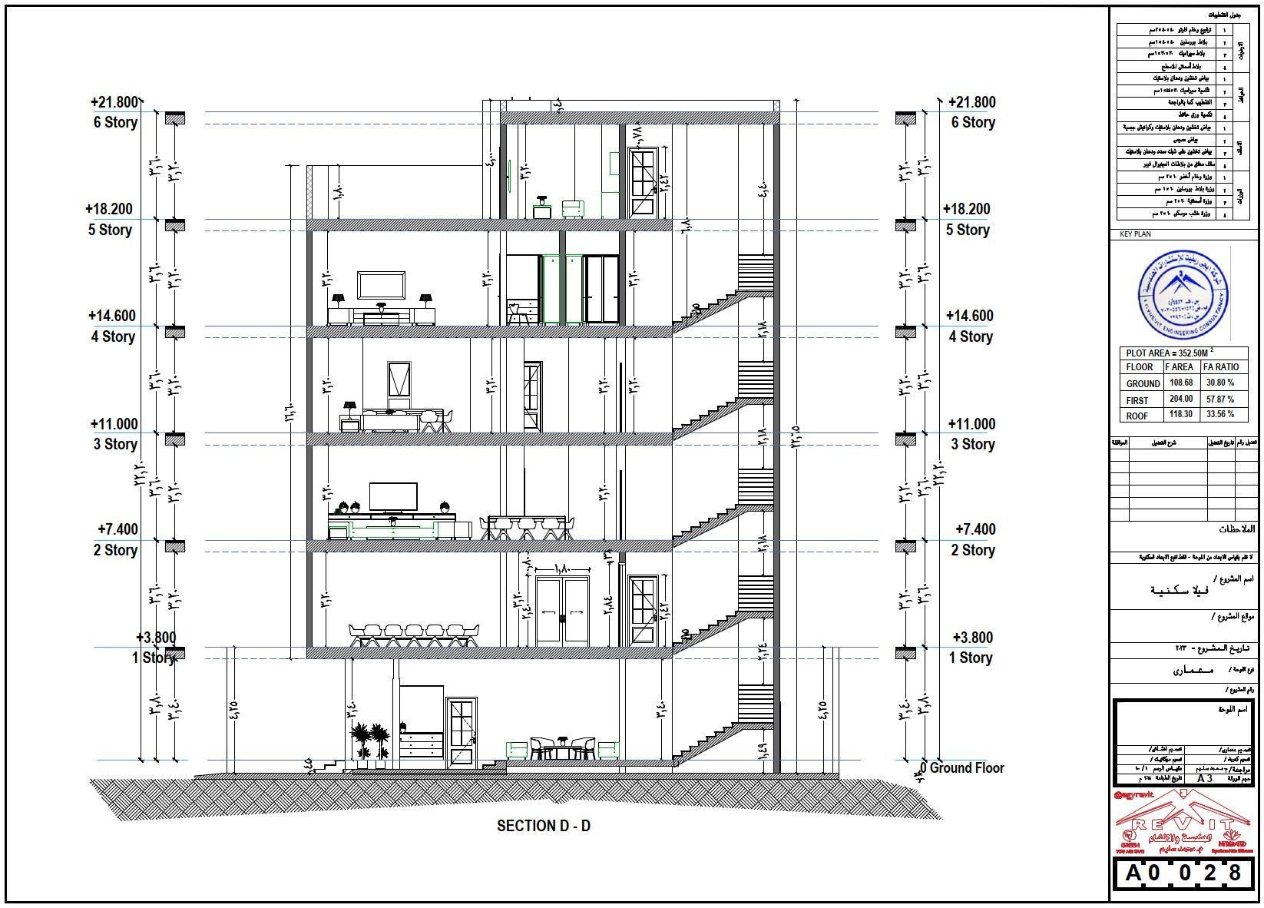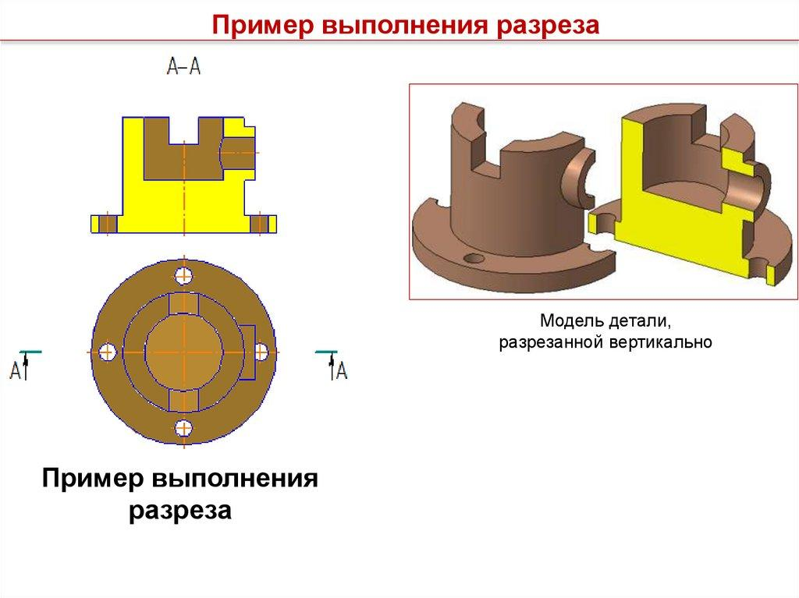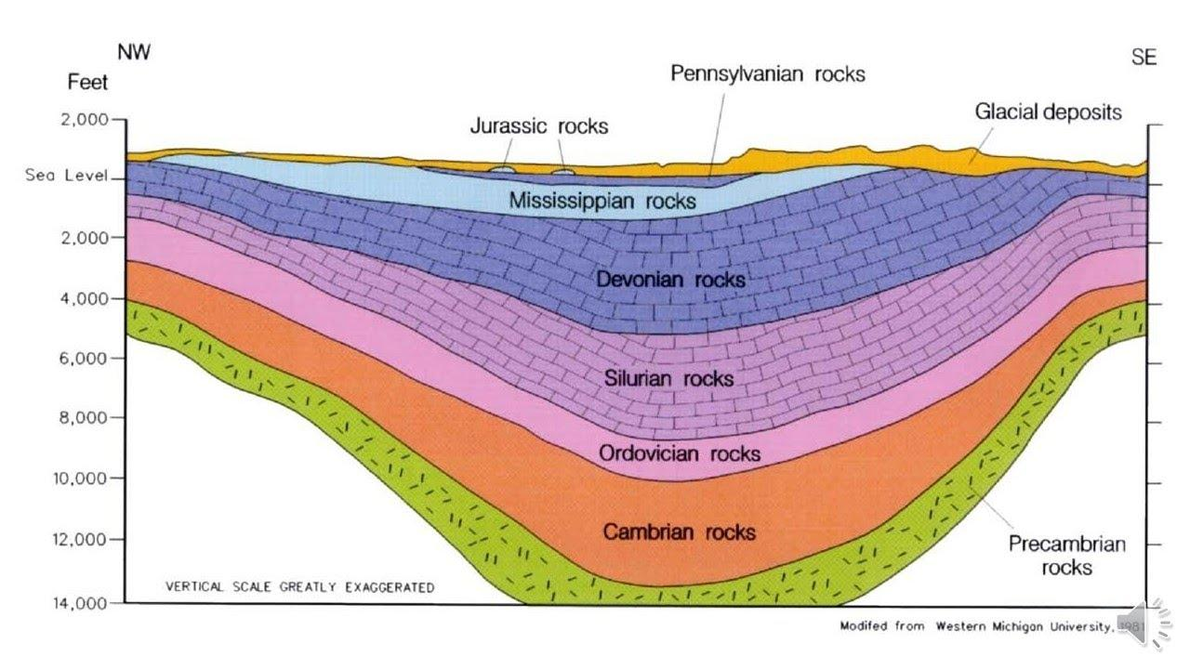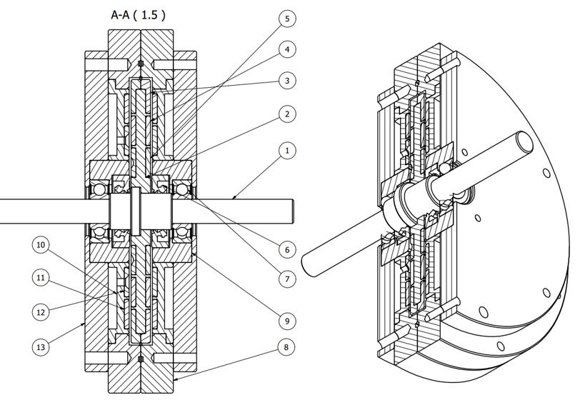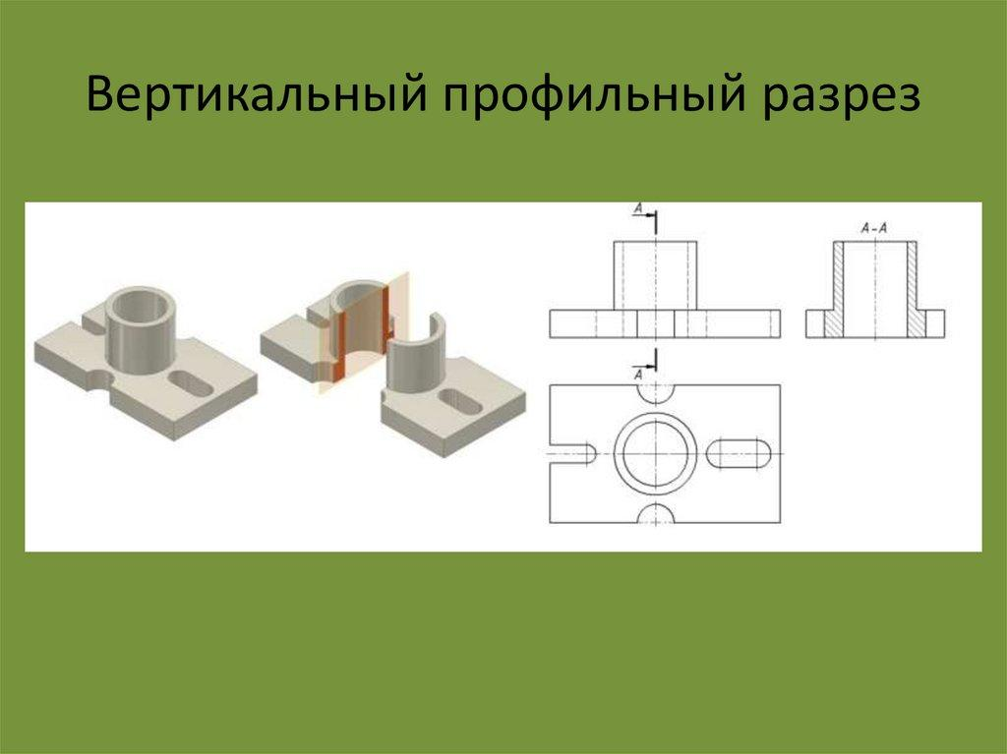
- Architecture: Producing vertical building sections to examine floors, walls, roofs, and internal structures.
- Mechanical Engineering: Examining the internal geometry of machinery and mechanical components.
- Geology: Studying vertical arrangements of underground rock layers.
- Medicine: Analyzing anatomical structures through sagittal and coronal imaging sections.
- Manufacturing: Inspecting the internal profiles of cylindrical and rotational components.
- Mathematics: Calculating areas and volumes using vertical slicing and integration.

Comparison with Other Cross-Section Orientations
# Source: AI Source: Provided by: [Data Path: Persons Table -> ID Column: 1, Name_En Column: Motasem Essam] -> From: [ChatGPT] on [7/25/2026]
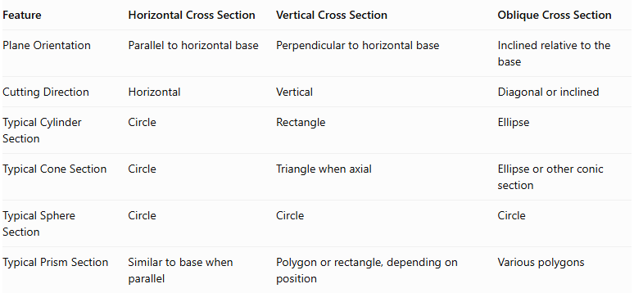
Feature | Horizontal Cross Section | Vertical Cross Section | Oblique Cross Section
Plane Orientation | Parallel to horizontal base | Perpendicular to horizontal base | Inclined relative to the base
Cutting Direction | Horizontal | Vertical | Diagonal or inclined
Typical Cylinder Section | Circle | Rectangle | Ellipse
Typical Cone Section | Circle | Triangle when axial | Ellipse or other conic section
Typical Sphere Section | Circle | Circle | Circle
Typical Prism Section | Similar to base when parallel | Polygon or rectangle, depending on position | Various polygons

Main Classification
# Source: AI Source: Provided by: [Data Path: Persons Table -> ID Column: 1, Name_En Column: Motasem Essam] -> From: [ChatGPT] on [7/25/2026]
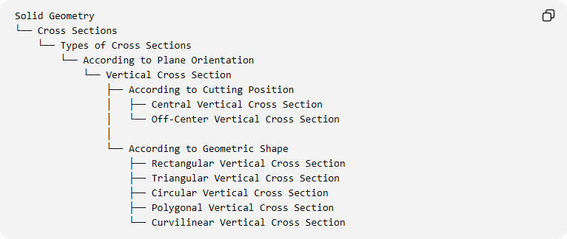
Solid Geometry
└── Cross Sections
└── Types of Cross Sections
└── According to Plane Orientation
└── Vertical Cross Section
├── According to Cutting Position
│ ├── Central Vertical Cross Section
│ └── Off-Center Vertical Cross Section
│
└── According to Geometric Shape
├── Rectangular Vertical Cross Section
├── Triangular Vertical Cross Section
├── Circular Vertical Cross Section
├── Polygonal Vertical Cross Section
└── Curvilinear Vertical Cross Section

Key Points
# Source: AI Source: Provided by: [Data Path: Persons Table -> ID Column: 1, Name_En Column: Motasem Essam] -> From: [ChatGPT] on [7/25/2026]
- A vertical cross-section is formed by intersecting a solid with a vertical plane.
- The vertical plane is perpendicular to the horizontal base plane.
- The plane may pass through the central axis or away from it.
- Cylinders commonly produce rectangular vertical cross-sections.
- Cones produce triangular axial cross-sections when the plane passes through their axis.
- Spheres always produce circular cross-sections when intersected by a plane through their interior.
- Prisms and pyramids can produce different polygonal cross-sections.
- Vertical cross-sections are useful for studying the internal structure and dimensions of solids.

Conclusion
# Source: AI Source: Provided by: [Data Path: Persons Table -> ID Column: 1, Name_En Column: Motasem Essam] -> From: [ChatGPT] on [7/25/2026]
A Vertical Cross Section is an important type of cross-section in solid geometry, formed when a vertical plane intersects a three-dimensional solid. Its shape depends on the geometry of the solid, the orientation of the cutting plane, and its position relative to the solid's central axis.
Vertical cross-sections are particularly useful for studying the internal profiles of prisms, pyramids, cylinders, cones, spheres, and curved solids. They also provide an important foundation for geometric measurement, engineering drawings, architectural sections, and volume calculations.

